
Spring 2026
GIFT School of Engineering and Applied Sciences

SE-317L: Software Project Management

Lab Manual 5
Microsoft Project

Introduction to the Lab:

This lab introduces students to project scheduling, resource management, task dependencies, and baseline setting in Microsoft Project. Using a real-world scenario, students will learn how to plan, organize, and track a project effectively.

The lab is based on the University Examination & Management System (UEMS) project for the University of Punjab. Students will experience the practical challenges of managing a large-scale software project involving multiple tasks, resources, and deadlines, while learning how to use MS Project tools to handle scheduling, resources, dependencies, and baseline tracking.

Objectives of this Lab

By the end of this lab, students will be able to:

- Create and structure project tasks in MS Project.
- Assign resources (work, material, and cost) to tasks.
- Define task dependencies (FS, SS, FF, SF) with lead and lag times.
- Save a project baseline to track schedule, duration, and cost variance.
- Use the Gantt Chart to visualize project progress and critical path.

Today's Task
What we will do today: Assign resources, Task Dependencies(FS, SS, FF, SF) , baseline to track schedule, duration, and cost variance.
Tool we will use: Microsoft Project — Assigning Resource to Task.

3-Hour Lab Breakdown
Time | Activity
0–30 min | Concept recap
30–90 min | Guided hands-on task
90–150 min | Independent student work
150–180 min | Evaluation + viva + submission

Assigning Resources to Tasks

Types of Resources
MS Project supports three types of resources. Understanding them is essential before assignment:
Type | Examples | How Cost is Calculated
Work | Team members, consultants | Hourly or daily rate × hours worked
Material | Lumber, concrete, software licenses | Cost per unit × quantity consumed
Cost | Travel expenses, permits | Fixed cost entered manually per assignment

Step 1: Creating a Resource Pool
Before you can assign resources, you must define them in the Resource Sheet.
- Open Resource Sheet — Click View tab → Resource Views group → Resource Sheet
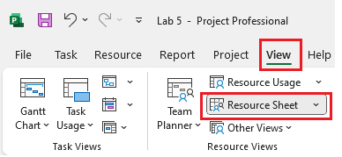
- Enter Resource Details — Fill in columns: Resource Name, Type, Max Units, Std. Rate, Ovt. Rate, Base Calendar
- Assign a Calendar — Click the Base Calendar dropdown and select Standard, Night Shift, or a custom calendar
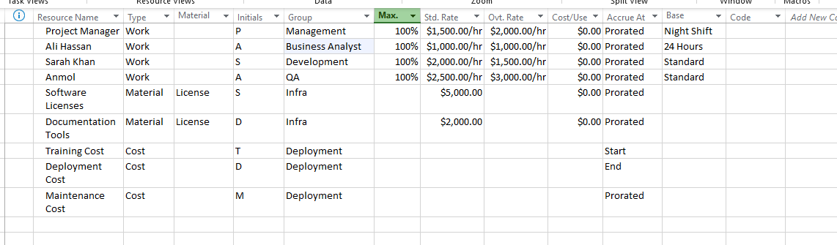

Critical Thinking:
What happens if one resource is overloaded?

Step 2: Assigning Resources via Gantt Chart
The fastest way to assign resources is directly from the Gantt Chart view:
- Switch to Gantt Chart view: View tab → Task Views → Gantt Chart.
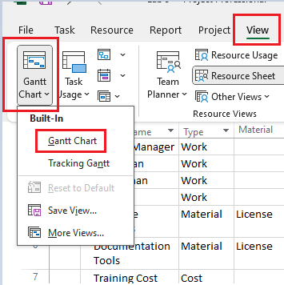
- Click on the task row where you want to assign a resource.
- In the Resource Names column (far right of the task table), click the dropdown arrow.
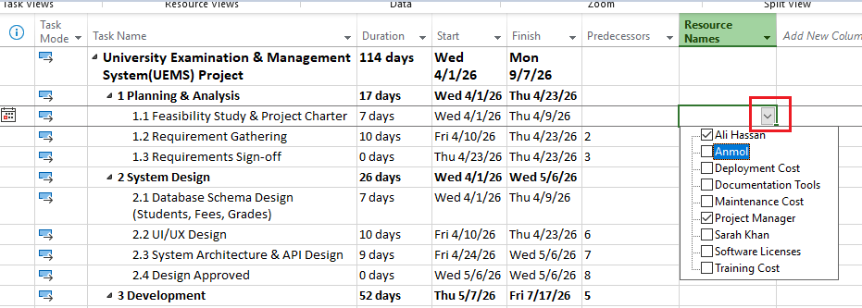

- Select one or more resources from the list. Multiple resources are separated by commas.
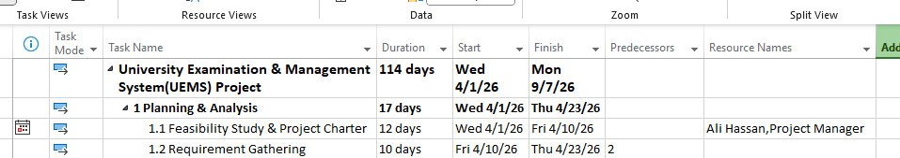
- Press Enter. The resource names appear next to the task bar on the chart.
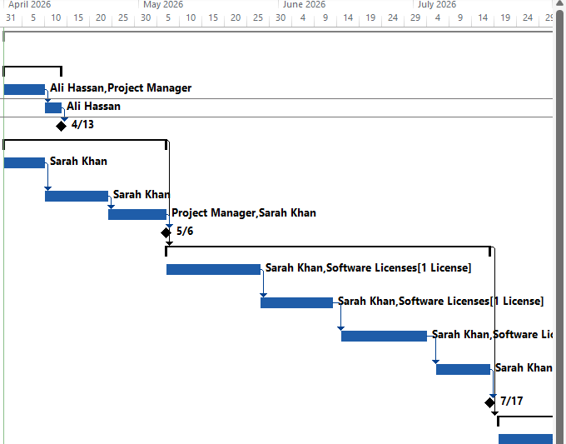
Tip | If the Resource Names column is not visible, right-click any column header → Insert Column → select Resource Names.

Step 3: Resource Assignment via Task Information Dialog
For more control over assignment units and costs, use the Task Information dialog:
- Double-click any task to open the Task Information dialog box.
- Click the Resources tab.
- In the Resource Name column, click the dropdown and select a resource.
- In the Units column, set the percentage (e.g., 100% = full-time, 50% = half-time).
- Click OK to confirm. MS Project automatically recalculates work hours.
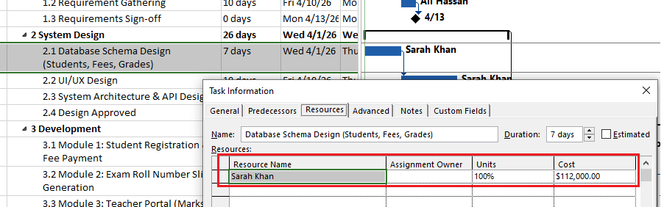
Add Cost Type : Cost
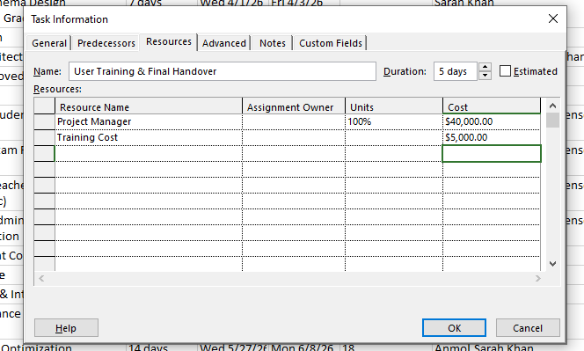
Step 4: Defining Task Dependencies

Understanding Dependency Types
Task dependencies (also called links or relationships) define the sequence in which tasks must be performed. MS Project supports four dependency types:
Type | Code | Description & Example
Finish-to-Start | FS | Task B cannot start until Task A finishes. (Most common — e.g., Testing cannot start until Development finishes)
Start-to-Start | SS | Task B cannot start until Task A starts. (e.g., Documentation can start when Development starts)
Finish-to-Finish | FF | Task B cannot finish until Task A finishes. (e.g., QA Review finishes when Testing finishes)
Start-to-Finish | SF | Task B cannot finish until Task A starts. (Rare — used in just-in-time scheduling)

Setting Dependencies via Link Tool
Method 1: Using the Toolbar (Recommended for Quick Linking)
- In the Gantt Chart view, click on the predecessor task row.
- Hold Ctrl and click the successor task row to select both.
- Click the Task tab → Schedule group → Link Tasks button (or press Ctrl+F2).
- MS Project creates a Finish-to-Start dependency between the two tasks.
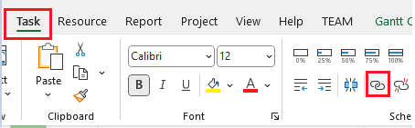
Method 2: Using Task Information Dialog
- Double-click the successor task to open Task Information.
- Click the Predecessors tab.
- In the Task Name column, click and select the predecessor task.
- In the Type column, choose the dependency type (FS, SS, FF, SF).
- Enter any Lag or Lead value.
- Click OK.
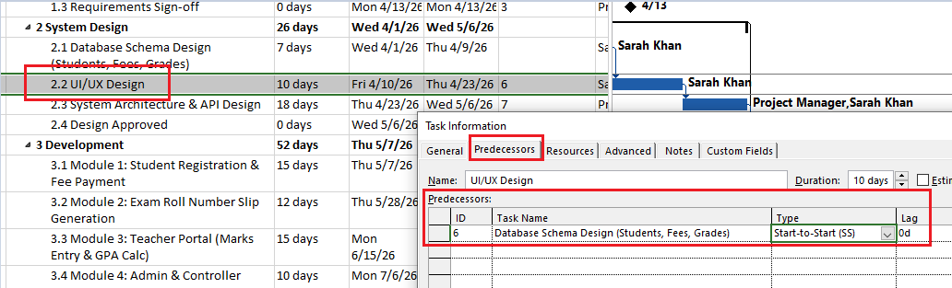
Or you can write 6SS in Predecessors column.

Step 5: Adding Lead & Lag Time
Lead and Lag times modify the standard dependency timing:
Concept | How to Enter | Example Use Case
Lag Time (Delay) | Enter positive value in Lag field (e.g., +2d) | Wait 2 days after concrete is poured before applying finish coating
Lead Time (Overlap) | Enter negative value in Lag field (e.g., -1d or -50%) | Start writing user docs 1 day before development finishes

Tip | To enter lead/lag: Task Information → Predecessors tab → Lag column. Enter positive days for lag (e.g., 2d) or negative for lead (e.g., -1d). You can also use percentage (e.g., -50% = start halfway through predecessor).

Step 6: Setting the Baseline
Before tracking begins, you must save a baseline — a snapshot of your original plan (start dates, finish dates, durations, costs, work). This becomes the reference point for all variance analysis.
- Open Set Baseline Dialog — Project tab → Schedule group → Set Baseline
- Select Baseline — Choose Baseline (for the main baseline) or Baseline 1–10 (for interim plans)
- Set For — Choose Entire Project or Selected Tasks only
- Confirm — Click OK. Baseline data is now saved in Baseline Start, Baseline Finish, and Baseline Duration fields
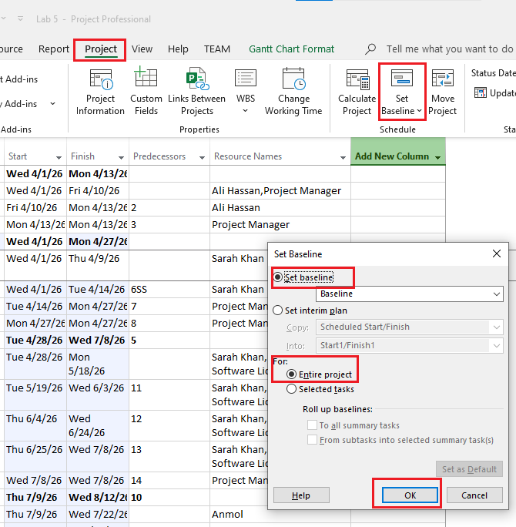

Tip | MS Project stores up to 11 baselines (Baseline, Baseline 1–10). Use Baseline 1, 2, etc. when significant scope changes occur to preserve the original plan for comparison.
Project Scenario
Scenario — University Student Portal
The University of Punjab has over 40,000 students enrolled across 120 departments. Every semester, students must visit the university in person to register for exams, pay fees manually, and collect their roll number slips from the office. This process takes weeks and causes long queues, lost paperwork, and errors in student records.
When exam results are ready, the university takes 45 to 60 days to calculate grades manually and notify students. Students have no way to check their results online — they must visit the notice board or wait for a letter. Many students also report incorrect marks due to human error.
To address these problems, the university has contracted TechBridge Solutions to build an online system called the University Examination & Management System (UEMS). This web-based portal will allow students to register for exams online, pay fees via mobile, download roll number slips instantly, and view results as soon as they are published.
Teachers will be able to enter marks online, and the system will automatically calculate GPA and CGPA — eliminating manual errors. The Examination Controller will generate reports and publish results in just 15 days instead of 60. The total project budget is PKR 28,00,000 and the deadline is 6 months (March 2025 – August 2025), so that students can use the system from the very next semester.

Lab Task
- Create 5 project tasks and assign different durations
- Create 3 tasks and link them using FS (Finish-to-Start)
- Create 3 tasks and link them using SS (Start-to-Start)
- Assign 2 resources to a task and set one resource to 50% units
- Add one Material resource and assign it to a task
- Add one Cost resource (e.g., travel) to a task
- Create task dependencies using FF (Finish-to-Finish)
- Create task dependencies using SF (Start-to-Finish)
- Add lag time (+2 days) between two tasks
- Add lead time (-1 day) between two tasks
- Save a baseline for the project
- Change duration of one task and observe changes in Gantt Chart
- Submission: Submit file named UEMS_YourName_RollNo.
Ethics Case Study
The University Examination & Management System (UEMS) handles sensitive information for over 40,000 students, including their National ID (CNIC), academic marks, and financial fee records. During the development phase, you discover that a developer (assigned as a Work Resource in your MS Project) has secretly copied real student data onto a personal drive and created a "backdoor" (unauthorized entry) in the system to access records later.
As the Project Manager, what immediate steps will you take against this specific resource? How will you ensure Data Integrity and security for the rest of the project? (Hint: Think about how you would change resource permissions or task monitoring in the future).

